**Cover sheet/Title page**

**Requirements Documents** <1>

Requirements Definition <pg 1>

**Requirement Specification Documents** <pg>

Use case diagram <pg 4-9>

Use case flow of events <pg num>

Class diagrams <pg 10>

Class documentation <pg num>

ER diagram(s) <pg num>

Decision table or state transition diagram <pg 13>

Requirements Definition

<Each functional and nonfunctional requirement should follow the user story style and have a Unique ID (this will assist in the completion of the system design docs). >

1. Functional Requirements

**Frontend Requirements:**

FE.F1: Intuitive Design

Description: As a user, I would like the program to be beginner friendly and easy to master. As well as consistent so that it can be easily navigable.

FE.F2: Pleasant Design

Description: As a user, I would like the application to have neatly organized screens that are also pleasant for the user to look at. I would like for the application to be easy to see such as having no colors too dark or colors too bright.

FE.F3 Login

Description: As a user, I would like the login screen to successfully log me in to my account and give me the proper selection screen according to my status. I also want the login screen to reject any wrong credentials from logging in

FE.F4 Selections

Description: As a user, I would like the application to have all the selections well formatted and each selection to lead me to the appropriate action.

FE.F5 Feedback

Description: As a user, I would like the application to provide me with feedback incase of anything so that I am aware that the application is responding

FE.F6 Forms and Information

Description: As a user, when I fill out anything like a customer's information or an order I would like the form to be neat, well organized, labeled, and successfully send or save the form/information once I submit.

**Backend Requirements:**

**BE.F1 User Login/Logout & User Recognition**

Description: As a developer, the program should be able to connect valid login information to the corresponding user profile and give them permissions befitting the users’ authorization (Customer or Sales Representative). The program should also properly log users out

**BE.F2 Order Sheet Creation**

Description: As a customer/sales rep, I want the program to create an order sheet using the information I enter.

**BE.F3 Adding/Removing Customers**

Description: As a sales rep, I need the program to give me the ability to add customers to my profile that have been assigned to me as well as remove those that are no longer assigned nor associated to me anymore.

**BE.F4 Altering Customer Information/Order Sheets**

Description: As a sales rep, the program should authorize me with the permissions to carry out edits to customer information and order sheets.

**BE.F5 Route Determination**

Description: As a sales rep, the program should authorize me with the permissions to carry out edits to delivery routes or access route information if necessary.

2.  Non-Functional Requirements

FE.NF1 Usability

Description: As a user I want a program to have an intuitive user interface, buttons need to be laid out in a fashion that is easy to understand and locate. All pages and screens need to have a uniform design and layout to help with this.

FE.NF2 Quickness

Description: As a developer, I would like the application to quickly respond to the actions the user selects or does on the application.

FE.NF3 Scalability

Description: As a developer, it should be easy to add onto the existing program. Such as an additional page/screen or a new product.

Requirements Specification

1. Use Case Diagram

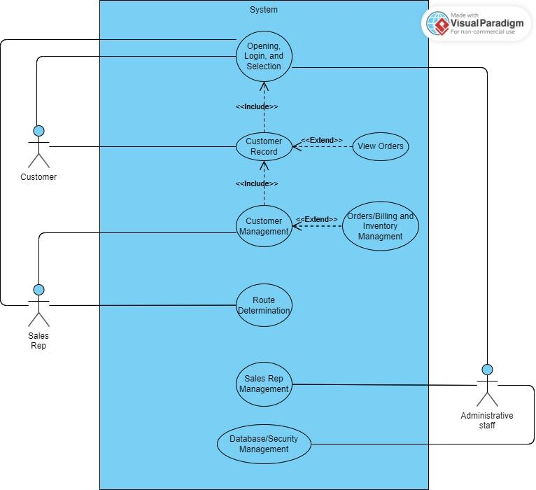

2. Use Case Flow of Events

**1.0 Flow of events for the Opening, Login, and Selection Use case**

**1.1 Preconditions**

* The user selects the login screen from the opening screen
* The user has their proper credentials

**1.2** **Main Flow**

This use case begins when the user is presented with the login screen after selecting the option from the opening screen. The user then must enter their credentials (username and password). Once the credentials are cleared as valid (E1), the user will then be presented with the selection screen where they can then select their next action. The options are CUSTOMER RECORD, CUSTOMER MANAGEMENT, ROUTES for sales rep with customer being excluded from the other two. Administrative staff will have the additional options of SALES REP MANAGEMENT and DATABASE/SECURITY. Lastly the option to log out is available and the user can exit the program by selecting it when at the opening screen where the use case would end.

* if CUSTOMER RECORD is selected, customer record use case is performed
* if CUSTOMER MANAGEMENT is selected by a sales rep, customer management use case is performed (E2)
* if ROUTES is selected by a sales rep, the routes use case is performed (E3)
* if an admin selects the SALES REP MANAGEMENT, the sales rep management use case is performed (E4)
* if an admin selects DATABASE/SECURITY, the database and security use case will be performed (E5)

**1.3 Subflows**

S-1 Log out

The user would be presented with a screen that asks them if they are sure they would like to log out. If the user selects confirm they would be returned to the opening screen. The use case terminates.

S-2 Exiting the application

If the user selects the exit option from the opening screen the application would close down. The use case terminates.

S-3 Selections

The user can select their next action according to the selections presented. The use case continues.

**1.4 Alternative Flows**

E-1: An invalid username or password is entered. The user can either reenter their credentials or terminate the use case.

E-2: The customer management is attempted to be accessed by a user who is not a sales rep. The program would display a message saying “unauthorized user” and the user can reselect an option or terminate the use case.

E-3: The routes are attempted to be accessed by a non-authorized user. The program would display a message saying “unauthorized user” and the user can reselect an option or terminate the use case.

E-4: The sales rep management is attempted to be accessed by a non-admin user. The program would display a message saying “unauthorized user” and the user can reselect an option or terminate the use case.

E-5: The database and security is attempted to be accessed by a non-admin user. The program would display a message saying “unauthorized user” and the user can reselect an option or terminate the use case.

**2.0 Flow of events for the Customer Record use case**

**2.1 Preconditions**

* The user is a customer or sales representative

**2.2 Main Flow**

This use case begins when a user selects the customer record option from the selection screen. Once entered the user will be prompted to enter a customer ID (E1) and if the ID is valid then the user can see the information of the customer and have the option to view orders. The user also has the option to contact a sales rep for an order. As well as an option to return to the selection screen

**2.3 Subflows**

S-1 View orders

The system will retrieve the orders from orders/billing database and print out the orders for the user to see. The use case continues. (E2)

S-2 Requests

The system will notify the sales rep of the customer that they would like a request for either a change in information or an existing order, or request for a new order. The use case then begins again. (E3)

S-3 Return

The system will return the user to the selection screen where they can make another option.

**2.4 Alternative Flows**

E-1: A customer attempts to enter in a customer ID that is not theirs or an invalid user ID. The program would display a message saying “unauthorized access” and the user can reenter an ID or terminate the use case.

E-2: The orders cannot be displayed or there is no order history. The user will be notified that the option is not available and the customer can contact their sales rep or terminate the user case.

E-3: The system cannot send a request to a sales rep. The user will be notified that it is unavailable at the time and have the option to report the bug. The use case continues.

**3.0 Flow of events for the Customer Management use case**

**3.1 Preconditions**

* The user must be a sales representative
* Customer credentials are required

**3.2 Main Flow**

This use case begins when the user (Sales rep) selects the customer management option from the selection screen once customer credentials are inputted (E1). From here the sales representative will be able to place an order for the customer, including type of product, quantity, etc (E2). The order can be placed using a submit button at the end of the order screen. The sales rep can also back out of the order screen, ending the sale.

**3.3 Subflow**

S-1 Placing order

Once a customer requests the order from the sales representative, the representative will be able to input the order into the system. Working with the customer to work around out of stock and backorder items.

S-1 Cancel order

Customer can contact sales rep to cancel order if possible

#### 3.4 Alternative Flows

E-1:The user is not a sales representative. The system will deny access and display the message “unauthorized user.” The user can then select another option or terminate the use case.

E-2: The customer credentials entered are invalid. The user can reenter the correct credentials or terminate the use case.

**4.0 Flow of events for the Route Determination use case**

#### 4.1 Preconditions

* The user must be a sales representative
* Customer credentials are required

**4.2 Main Flow**

This use case begins when a sales representative selects the routes option from the selection screen. Once the customer credentials have been inputted (E1), the sales rep can then determine the best route to visit each customer (E2).

**4.3 Subflow**

S-1 Modify route

The sales rep can adjust the route by adding or removing stops, changing the order of visits, etc. Once satisfied, the rep can confirm the route and the use case continues.

**4.4 Alternative Flow**

E-1: Customer credentials are not valid, the user can re enter the information or end the use case.

E-2: Best route is unavailable and work around it necessary

**5.0 Flow of events for the Sales Rep Management use case**

**5.1 Preconditions**

* **User must be an admin**
* **User must have sales representative information**

**5.2 Main Flow**

This use case begins when an admin (E1) selects the Sales Rep Management option from the selection screen. Here the admin can add a new sales representative (E2) and/or update their information. The system will also allow the option to display the information of all the sales representatives currently on the system. (E3)

**5.3 Subflow**

S-1 Add sales representative

The system will allow the admin to add a new sales representative to the system. The admin will be presented with a field to add in the new sales rep and their ID. Once done the use case begins again.

S-2 Modify sales representative information

The system will retrieve and display the information of the specific sales rep (E5). Then will allow the admin to modify fields containing the sales rep information. Once the admin is done they can save & submit and the use case will begin again.

S-3 View sales reps on system

The system will retrieve and display all the sales representatives currently on the system. The use case will continue.

**5.4 Alternate Flow**

E-1: The user is not an admin. The system will deny access and display the message, “unauthorized user”. The user can then select another option or terminate the use case.

E-2: The user does not have all the proper information. The user can obtain the correct information and fill them into the proper fields or terminate the use case.

E-3: The list of sales representatives is not displayed. The user will be notified that it is currently unavailable and will be fixed soon. The user can restart the use case or terminate it.

E-4: The user enters invalid sales representative ID. The user will be prompted to enter a correct ID or terminate the use case.

**6.0 Flow of events for the Database/Security Management use case**

**6.1 Preconditions**

* User must be an admin

**6.2 Main Flow**

The use case will make the system allow an admin to have the option to view the database for all the customers, sales representatives, orders/billing information and routes. The admin will also have the option to see any failed attempts in accessing unauthorized options from the selection screen. Finally the user can return to the selection screen using the return option.

**6.3 Subflows**

S-1 Display data

The system will display all the information to the admin for them to look over but will not be able to edit it. The use case will continue (E2).

S-2 View security

The system will display everytime a failed attempt to login or access something occurs. The admin will also be able to see all the times the system had an error reported. The use case will continue if the user returns to the option screen. (E3)

**6.4 Alternate flows**

E-1: The user is not an admin. The system will not allow access to the database or security and it will display a message saying, “access denied: unauthorized user”. The user case begins again

E-2: The database is not displaying information or all the information. The user would be notified that the information cannot be displayed at the current time and the user can terminate the use case.

E-3: The security log is not displaying. The user would be notified that the information cannot be displayed at the current time and the user can terminate the use case.

3. Class Diagrams

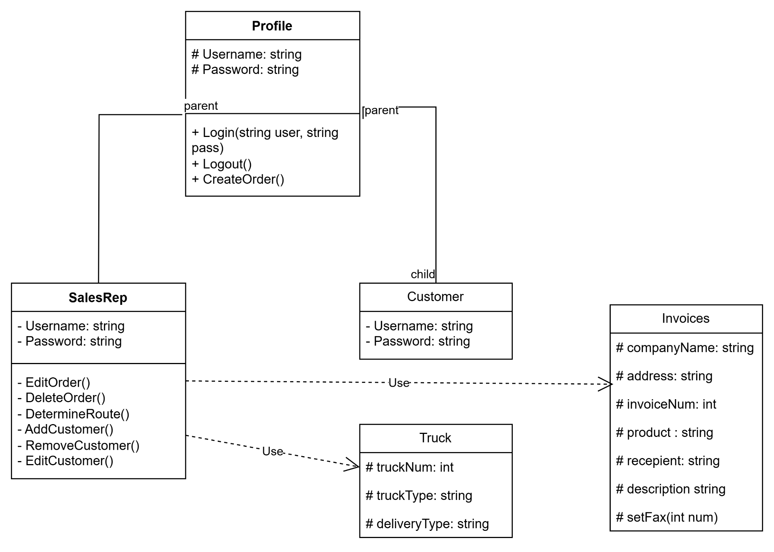

<Insert the UML class diagrams for the system. At this point of development the diagrams should show the class name and the relationship between the classes (inheritance, dependency, association, aggregation, multiplicity. If necessary, use more than one page rather than shrinking it to fit.>

4. Class Documentation

<The class documentation should consist of 3 or 4 sentences describing the class, its functions and interactions.>

**Profile**

An abstract parent class that the Customer and Sales Rep classes will inherit from. This class has the username and password properties which all Customer/Sales Rep child classes will need. It also has the Login(), Logout(), and CreateOrder() methods that will allow Customer/Sales Reps to log in and out of their accounts and create orders.

**Customer**

Child class of Profile, it will inherit all of the properties and methods of Profile. It’s the most rudimentary account and currently only has the properties and methods that profile has, it has yet to be determined what else should be added to the Customer class.

**Sales Rep**

Child class of Profile, it will inherit all of the properties and methods of Profile. The sales rep class also has its own unique methods. EditOrder() will allow Sales Reps to adjust Order Sheets. DeleteOrder() will allow Sales Reps to remove order sheets, and DetermineRoute() will allow sales reps to select delivery routes. AddCustomer() will allow sales reps to assign customer(s) to their dashboard, RemoveCustomer() does the opposite, and EditCustomer() allows them to edit customer information if permissible.

**Truck and Invoices**

This class will have truck and invoice info that will be used to create order sheets. Truck and Invoice objects will be created from these classes and accessed by sales reps to use in their order sheets. Info that contains but not limited to: truckID, companyName, recipient, deliveryType, etc.

5. ER Diagram

<Insert the ER diagram using the classic design pattern, not tables, showing data and its relationships as it is stored in the database. If necessary, use more than one page rather than shrinking it to fit.>

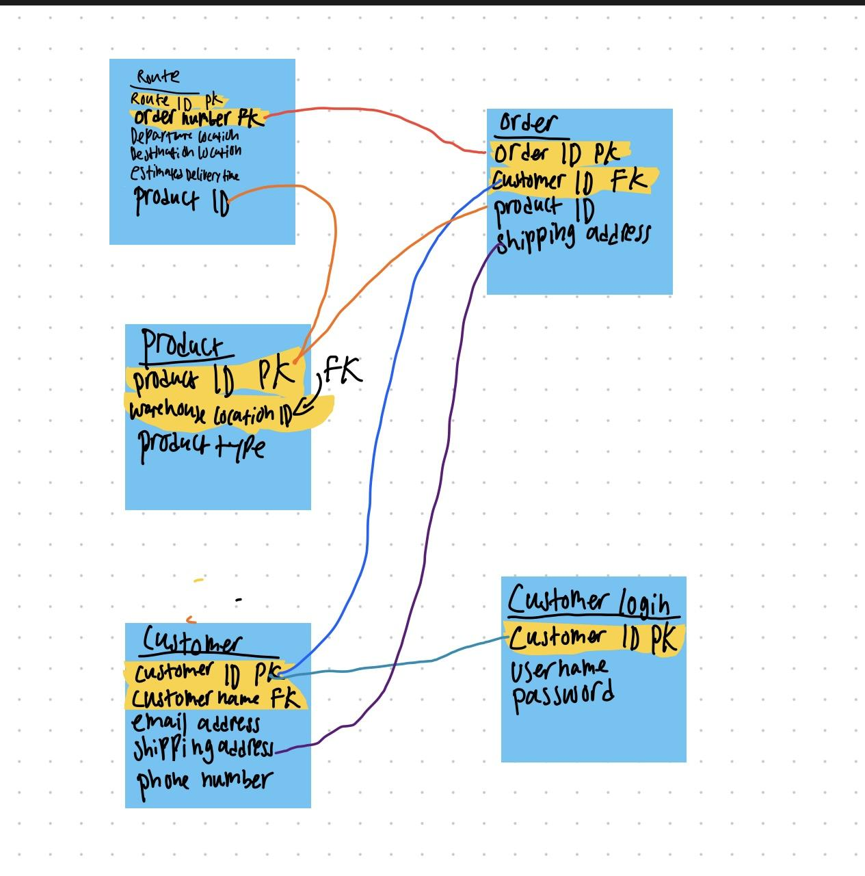

6. Decision Table **or** State Transition Diagram

State Transition Diagram

